# Media Mover Quick User Guide

Media Mover is a software program that copies and organizes files captured by a Mission Cam system in preparation for their conversion into a panorama by [VideoStitch](https://missionroom.atlassian.net/wiki/display/SUPPORT/VideoStitch).

This guide will give you step by step instructions for moving video files from the Mission Cam to the Mission Edit laptop.

Media Mover has other functions which are explained in the full User Manual available online via www.missionroom.com/support.

### 1. Connect SD cards to the Laptop and start Media Mover

1. Insert the SD cards from Mission Cam into the USB Hub
2. Connect the USB to your Mission Edit laptop
3. Start Media Mover on the laptop by double clicking the Media Mover icon

### 2. Select a File Type and Process

1. Make sure the File Type is set to ‘Videos’
2. Make sure the Process is set to ‘Re-arrange videos’

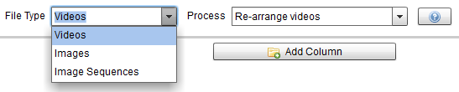’

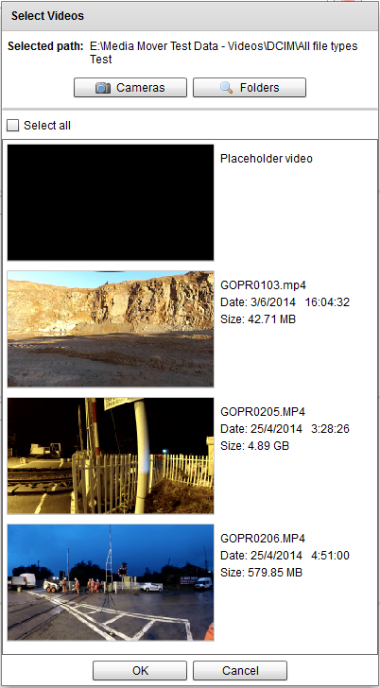

### 2. Add Columns and Files

1. Click on ‘Add Column’ . A popup box will appear
2. Click on ***'Cameras'*** button
3. Select a Camera folder and double click on it.
4. The file selection window will appear.
5. Choose specific files or the select all option
6. Click ‘Ok’
7. Repeat this process for all four Cameras

### 3. Re-arrange Videos

1. When all four cameras have been added there will be four columns of thumbnails
2. Identify features on the edge of each image - matching them with the same features in the adjacent image
3. Change the order of the columns by **clicking the left and right arrows** at the top of the column

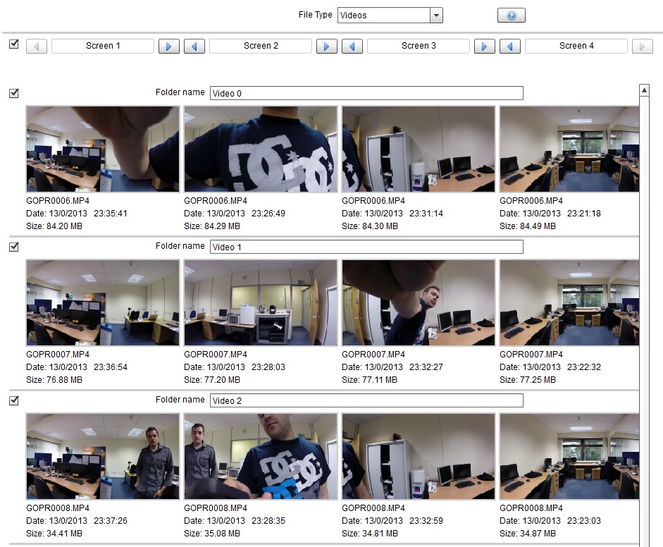

### 4.Transfer Files

1. Start the transfer process by clicking on the '***browse***' button at the bottom of the screen.
2. Choose where to save your videos and click ‘select folder’
3. Click '**Transfer’**
4. The transfer window will open and the files will start transferring
5. 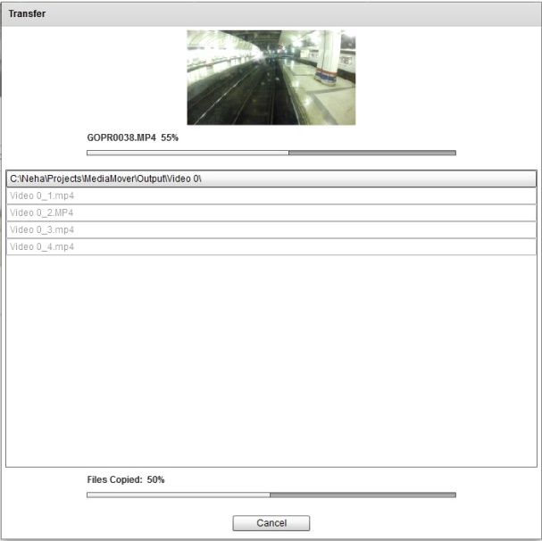When complete, the files copied progress bar will show 100%
6. Click a folder item in the list will open that folder
7. Click the '***Close***' button to finish.
8. Close Media Mover by clicking on ‘X’ at the top right of the screen.