Mission Cam 4

User Manual

|  |  |
| --- | --- |
| Manufacturer: | Mission Room Ltd  Kings Meadow Campus  Lenton Lane  Nottingham  NG7 2NR  UK  Tel : +44 (0)115 951 6800  Email : info@missionroom.com |

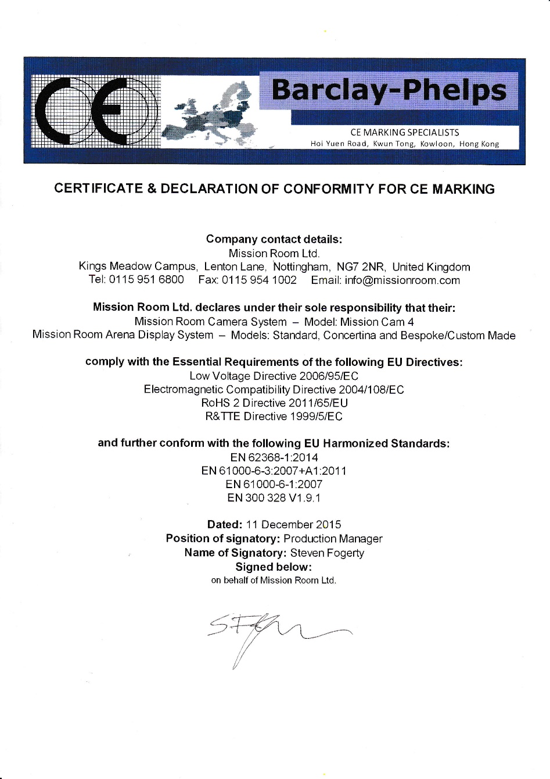

Product Description

Mission Cam 4 is a 360° camera used to capture images and videos for use with a Mission Room display system. The camera system includes the camera, tripod, accessories and a carry case.

System contents

|  |  |  |  |  |  |
| --- | --- | --- | --- | --- | --- |
| **Component** | **Quantity** | **Component** | **Quantity** | **Component** | **Quantity** |
| Dual battery charger | 2 | Waterproof case | 1 | MicroSD card reader | 4 |
| Hub AC adapter | 1 | USB3 Hub | 1 | Mini USB cable | 1 |
| Tripod | 1 | Spare GoPro batteries | 4 | GoPro clear plastic housing | 1 |
| MC4 Housing Top (with badge) | 1 | MC4 Housing Base | 1 | MC4 Housing Central post with locking screw and hot shoe | 1 |
| GoPro Hero 4 Black camera | 5 | 64gb MicroSD cards | 5 | USB3 lead | 1 |
| Tripod tilt head | 1 | GoPro Wi-Fi Remote | 1 | GoPro Wi-Fi Remote charging cable | 1 |
| GoPro batteries | 5 |  |  |  |  |

Mission Cam 4

Preparation

1. Ensure the MicroSD cards have sufficient space to accommodate your next filming session
2. Correctly insert the MicroSD card in each camera in turn
3. Ensure the camera batteries are fully charged prior to filming (including any extra batteries as required)
4. Ensure the lenses are clean

Camera assembly

1. Place the 4 GoPro cameras into the recesses on the bottom part of the housing first taking care to insert the correct numbered camera into the corresponding recess.
2. Fit the top of the housing over the cameras making sure to match the 2 notches up on the lens surrounds.
3. Fit the central mounting post through the rest of the housing and secure using the locking screw



It is of critical importance that the GoPro cameras are inserted into the housing in the correct order.

Failure to do this could result in poor image alignment at a later stage.

GoPro information

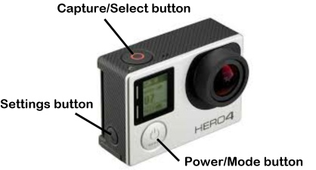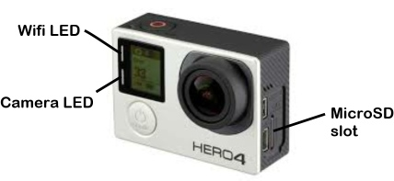

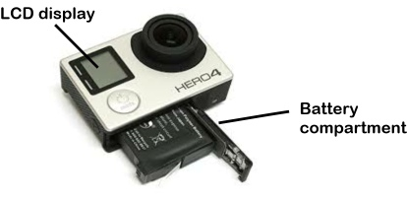

The GoPro cameras have already been setup ready for use so there is no need to change any of the settings on the camera.

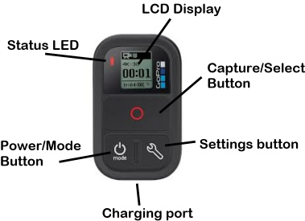

Using the camera

The Mission Cam housing is NOT waterproof. Using the housing in bad weather will result in damage to the cameras that is not covered by the warranty.

If there is a chance of bad weather transfer the cameras to the Mission Room waterproof housing (if provided)

Turning the cameras on

1. To turn the cameras on press the power button on each camera in turn
2. When the cameras are on check the LCD display to ensure that all of the cameras are fully charged

Turn on the Wi-Fi

1. Press and hold the settings button on the side of the camera until the display shows the Wi-Fi is on
2. Check the Wi-Fi LED is flashing blue on each one of the cameras

Turn on the Smart remote

1. Press the Power button to turn the remote on
2. Check the battery level on the remote to ensure it is fully charged
3. Cameras (with Wi-Fi turned on) will connect to the remote automatically
4. Smart remote will show how many cameras are connected on the LCD display

Check the Capture mode

1. Check the mode on the Smart remote before starting to capture media. We recommend using the video mode as still photos can be extracted from the video later in the process.
2. Pressing the Power/Mode button will cycle through all the available modes on the cameras

Position the Camera

1. Attach the camera to the tripod using the mount on the bottom of the camera
2. Camera will click into place
3. Make sure that the camera is level using the spirit level on the tripod. Also check the height is set correctly
4. Point the arrow on the top of the camera at the most important action point
5. Ensure that the important aspects of what you want to capture are towards the centre of camera lens

Start Capture

1. Check the Smart remote is connected to 4 cameras before pressing the Capture button
2. Press Capture button to capture media

Stop Capture

1. Check the Smart remote is connected to 4 cameras before pressing the Capture button
2. Press Capture button to stop media capture

Turning off the cameras

1. Press and hold the Start/Mode button on the remote.
2. Check that all 4 LCD displays are off.
3. Press and hold each camera's setting button (approx. 4 secs) in turn.
4. Check that all 4 blue lights are off.

Transferring files to the Edit System

1. Plan filming carefully, considering the potentially long transfer and processing times required for large amounts of media.
2. Carefully remove the MicroSD card from camera 1 and insert into the first card reader in the USB Hub provided.
3. Repeat with cameras 2, 3 and 4
4. Switch on your Mission Edit system and connect the USB hub.
5. Use Media Mover to transfer your files from the MicroSD cards to the external media drive provided

Recharge the cameras

1. Recharge the batteries to ensure they are ready for use

Only charge the batteries using the chargers and adapters provided. Use of other chargers or adapters may result in damage to the battery.

Caring for your camera

* We recommend storing the cameras in their housing in the waterproof case provided to minimise the chance of damage.
* To prolong the life of the camera batteries please ensure that the batteries are stored fully charged.

Do not drop, disassemble, open, crush, bend, deform, puncture, shred, microwave, incinerate or paint the camera. Do not insert foreign objects into the battery opening on the camera. Do not use the camera or battery if it has been damaged – for example, if cracked, punctured or harmed by water. Disassembling or puncturing the battery can cause an explosion or fire.

Do not store metal objects with the spare batteries as this may cause a short circuit resulting in a fire.

Troubleshooting

* Most issues that may arise are due to insufficient power.
* If any of the lights or displays show a persistent error message try removing the battery / re-insert and power up again
* Battery life will be reduced in extreme cold temperatures
* Screen error messages
  + NO SD – No microSD card present, please insert a card into the camera
  + FULL – Card is full, delete files or swap for a different card
  + SD ERR – Camera is unable to read the SD card. Reformat the card in the camera
  + File repair icon – This looks like a sticking plaster icon on the display, it will show this icon while trying to repair file corruption
  + Temperature icon – A thermometer will show on the display when the camera becomes too hot to operate correctly. This is normal operation for the camera to protect itself. If this shows let the camera sit and cool down before using again

If you are experiencing problems with your camera please contact Mission Room support.

Email – [info@missionroom.com](mailto:info@missionroom.com)

Tel – 0115 951 6800 (Normal office hours 8am to 5pm – Mon to Fri)